

**Faculty of Engineering and Technology**

**Electrical & Computer Engineering Department**

**Communication**

**Project**

**Prepared by:**

**Name:** mahmoud nobani **Id:**1180729

**Instructor**: Dr.wael

**Section**: 2

**Date:**12/9/2021

**Q1:**

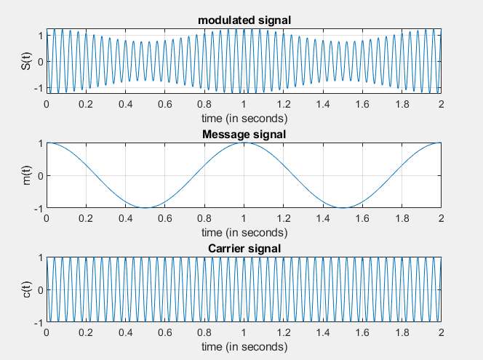

**Q2:**

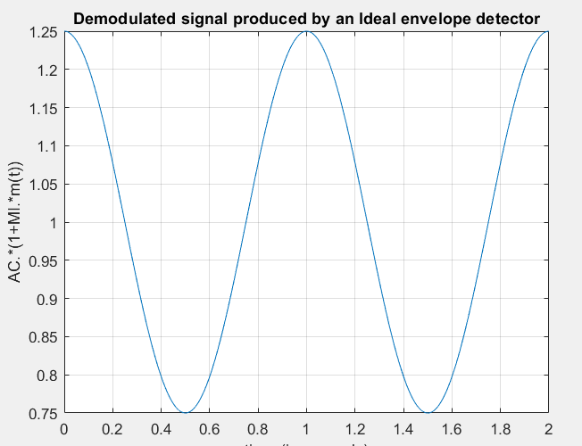

**As for the last part, unfortunately I wasn’t able to make the algorithm which calculate the practical envelope vector into a reality thus I wasn’t able to do any of the part left (a,b,c)**

**Just for contexts the algorithm tried to find/ detect the peaks if found we continue with the modulated signal, else we start with v0*exp, we will be able to do this hypothitacly with for loop and if statements:**

**Algorithms:**

**For 1:length(S)**

**If (peak)**

**Out=s**

**Else**

**Out=v0*exp**

**As for the mean square we use the same algorithm inside a loop of tau, then do the summation**

**Ideal tau hypothetically will be 0.74**

**I hope there will be a discussion for this project….**

**Code:**

clear all

close all

clc

%part 1

t=0:0.001:2;

MI=0.25;

c=cos(2.*pi.*25.*t);

m=cos(2.*pi.*t);

s=(1+MI.*m).*c;

subplot(3,1,1),plot(t,s,'-'),xlabel('time (in seconds)'),ylabel('S(t)'),title('modulated signal'),grid on;

subplot(3,1,2),plot(t,m,'-'),xlabel('time (in seconds)'),ylabel('m(t)'),title('Message signal'),grid on;

subplot(3,1,3),plot(t,c,'-'),xlabel('time (in seconds)'),ylabel('c(t)'),title('Carrier signal'),grid on;

%part 2

Ienv=abs((1+MI.*m));

figure

plot(t,Ienv,'-'),xlabel('time (in seconds)'),ylabel('AC.*(1+MI.*m(t))'),title('Demodulated signal produced by an Ideal envelope detector'),grid on;

%part3

for to=0.4:0.01:1

k=1; z=s(k)*exp(-t/to);

for i=1:length(z)

if z(i)>=s(i)

y(i)=z(i);

k=k+i;

else

y(i)=s(i);

end

end

end;

figure

plot(t,y),xlabel('time (in seconds)'),ylabel('Y'),title('Practical envelop'),grid on;